Hi Muhammad

Great post, very informative.

I believe the correct MX record for your site is: mail.customersrus.co.uk. achieved by executing the following command from a Linux/Mac terminal: nslookup -type=mx customersrus.co.uk 8.8.8.8 (image attached) or alternatively using an online tool such as MxToolBox (MxToolBox Inc, 2021).

In addition, it is interesting to note that your hardening solutions suggested by sitecheck (https://sitecheck.sucuri.net/results) mentions that a WAF (Web Application Firewall) is required. WAF’s run at layer 7 of the OSI model and can filter, monitor, and block malicious HTTP/S traffic destined to web applications (F5 Inc, 2021). Internet facing applications and websites require protection against SQL (Structured Query Language) injection, XSS (Cross-Site Scripting) attacks as well as cookie poisoning all of which a WAF can offer protection against (Fortinet Inc, 2021). However, the draw backs of WAF’s includes cost as these can be relatively expensive and performance as WAF’s need to inspect every packet thereby slowing down a network.

Furthermore, an SSL scan (image attached) from SSL Labs (Qualys, 2021) reveals that the server hosting the website supports TLS version 1.3 which is excellent. TLS 1.3 is more secure and a lot faster than its predecessor TLS version 1.2 (CloudFare Inc., 2021).

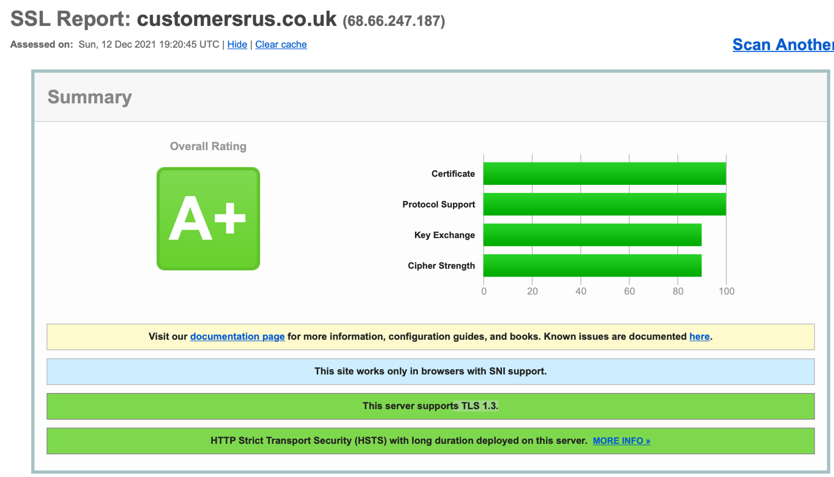

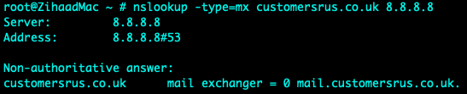

List of References

CloudFare Inc. (2021) Why use TLS 1.3? | SSL and TLS vulnerabilities. Available from: https://www.cloudflare.com/en-gb/learning/ssl/why-use-tls-1.3/ [Accessed 12 December 2021].

MxToolBox Inc. (2021) MX Lookup. Available from: https://mxtoolbox.com/MXLookup.aspx [Accessed 11 December 2021].
F5 Inc. (2021) What is a Web Application Firewall. Available from: https://www.f5.com/services/resources/glossary/web-application-firewall [Accessed 11 December 2021].
Fortinet Inc. (2021) Cross-site Scripting (XSS). Available from: https://www.fortinet.com/resources/cyberglossary/cross-site-scripting [Accessed 11 December 2021].

